# Acceptable Financial Reporting Framework Assessment

In determining the acceptability of the Financial Reporting Framework, consider the following factors:

* **The nature of the entity** (for example, whether it is a business enterprise, a public sector entity or a not-for-profit organization);
* **The purposes of the financial statements** (for example, whether they are prepared to meet the common financial information needs of a wide range of users or the financial information needs of specific users);
* **The nature of the financial statements** (for example, whether the financial statements are a complete set of financial statements or a single financial statement); and
* **Whether law or regulation prescribe the applicable financial reporting framework**.

Complete the following steps in assessing the Financial Reporting Framework.

|  |
| --- |
| 1. Identify the purpose of the Financial Statements (general purpose financial statements or special purpose financial statements). |
|  |
| 1. Determine whether the financial reporting framework to be applied in the preparation of the financial statements is acceptable. **(ref: CAS 210:6a, A2-A10))**   ***Refer to explanatory information and flow charts at the end of this document.*** |
|  |
| 1. If financial reporting standards established by an authorized or recognized standards setting organization are supplemented by law or regulation, determine whether there are any conflicts between the financial reporting standards and the additional requirements. If such conflicts exist, discuss with management the nature of the additional requirements and agree whether: 2. The additional requirements can be met through additional disclosures in the financial statements; or 3. The description of the applicable financial reporting framework in the financial statements can be amended accordingly.   If neither of the above actions is possible, determine whether it will be necessary to modify the auditor's opinion in accordance with CAS 705. **(ref: CAS 210:18)**  Document whether this situation applies and how you have resolved it. |
|  |
| 1. If you have determined that the financial reporting framework prescribed by law or regulation would be unacceptable but for the fact that it is prescribed by law or regulation, accept the audit engagement only if the following conditions are present: **(ref: CAS 210:19)**    1. Management agrees to provide additional disclosures in the financial statements required to avoid the financial statements being misleading; and    2. It is recognized in the terms of the audit engagement that: 2. The auditor's report on the financial statements will incorporate an Emphasis of Matter paragraph, drawing users' attention to the additional disclosures, in accordance with CAS 706; 4(4) and 3. Unless the auditor is required by law or regulation to express the auditor's opinion on the financial statements by using the phrases "present fairly, in all material respects," or "give a true and fair view" in accordance with the applicable financial reporting framework, the auditor's opinion on the financial statements will not include such phrases.   Document whether this situation applies and how you have resolved it. |
|  |
| 1. If the conditions outlined above are not present and you are required by law or regulation to undertake the audit engagement, you should: **(ref: CAS 210:20)**    1. Evaluate the effect of the misleading nature of the financial statements on the auditor's report; and    2. Include appropriate reference to this matter in the terms of the audit engagement.   Document whether this situation applies and how you have resolved it. |
|  |
| 1. Overall conclusion:   Summarize the impact on the financial statements, the terms of the engagement and on the auditor’s report and **carry this summary to the results section in procedure “Financial reporting framework”.** |
|  |

## Explanatory Information

### Types of acceptable general purpose financial reporting frameworks

The new audit reporting model expands the types of financial reporting frameworks for general purpose financial statements on which it is acceptable for the auditor to report.

CAS 210 provides for a much broader range of possible general purpose frameworks as depicted below. Previously, Canadian auditing standards made reference to Canadian GAAP when discussing general purpose financial statements. The acceptable financial reporting frameworks for general purpose financial statements under CAS 210 comprise those frameworks that:

* are established by a standard-setting organization authorized or recognized to promulgate standards that are presumed to be acceptable (referred to throughout as “GAAP”);
* encompass financial reporting standards established by an authorized or recognized standard setting organization, with additional requirements in law or regulation relating to the preparation of financial statements (referred to throughout as “GAAP” when the requirements do not conflict with the standards, and “non-GAAP” when they do conflict);
* are established by law or regulation, or by an other organization that is authorized to set accounting standards (such as an industry organization) that, in the absence of indications to the contrary, are presumed to be acceptable but may not be GAAP (referred to throughout as “non-GAAP”).

In most circumstances, the applicable reporting framework, as required by an entity’s incorporating legislation or by the securities legislation to which the entity is subject, will continue to be Canadian GAAP. When the International Financial Reporting Standards (IFRSs) are adopted in Canada for financial statements for periods beginning on or after January 1, 2011, the Canadian Securities Administrators have concluded that an entity would have a choice of describing the basis of accounting as either “in accordance with IFRSs” or “in accordance with IFRSs and Canadian GAAP”. The description of the financial reporting framework in the auditor’s report would be consistent with the description in the financial statements. **Refer to Auditor’s report Template**

### Preconditions for an Audit—per CAS 210:

*6. In order to establish whether the preconditions for an audit are present, the auditor shall:*

*(a) Determine whether the financial reporting framework to be applied in the preparation of the financial statements is acceptable; and (Ref: Para. A2-A10)*

*(b) Obtain the agreement of management that it acknowledges and understands its responsibility: (Ref: Para. A11-A14, A20)*

*(i) For the preparation of the financial statements in accordance with the applicable financial reporting framework, including, where relevant, their fair presentation; (Ref: Para. A15)*

*(ii) For such internal control as management determines is necessary to enable the preparation of financial statements that are free from material misstatement, whether due to fraud or error; and (Ref: Para. A16-A19)*

*(iii) To provide the auditor with:*

*a. Access to all information of which management is aware that is relevant to the preparation of the financial statements such as records, documentation and other matters;*

*b. Additional information that the auditor may request from management for the purpose of the audit; and*

*c. Unrestricted access to persons within the entity from whom the auditor determines it necessary to obtain audit evidence.*

Limitation on Scope Prior to Audit Engagement Acceptance

*7. If management or those charged with governance impose a limitation on the scope of the auditor's work in the terms of a proposed audit engagement such that the auditor believes the limitation will result in the auditor disclaiming an opinion on the financial statements, the auditor shall not accept such a limited engagement as an audit engagement, unless required by law or regulation to do so.*

Other Factors Affecting Audit Engagement Acceptance

*8. If the preconditions for an audit are not present, the auditor shall discuss the matter with management. Unless required by law or regulation to do so, the auditor shall not accept the proposed audit engagement:*

*(a) If the auditor has determined that the financial reporting framework to be applied in the preparation of the financial statements is unacceptable, except as provided in paragraph 19; or*

*(b) If the agreement referred to in paragraph 6(b) has not been obtained.*

### Refer to the following 5 charts for assistance in determining the acceptability of the Framework.

# Appendix 1: Overview of the New Reporting Model

## Chart 1—Determining Acceptability of Framework for General Purpose Financial Statements—CAS 210

The financial statements may be prepared in accordance with a financial reporting framework designed to meet the common financial information needs of a wide range of users (i.e., "general purpose financial statements" prepared in accordance with a "general purpose framework"). The following chart explains the types of general purpose frameworks discussed in CAS 210

|  |  |  |
| --- | --- | --- |
| Type of Framework | Criteria for Acceptability | Auditor Action |
| Financial reporting standards established by organizations that are authorized or recognized to promulgate standards to be used by certain types of entities. **CAS 210, paragraphs A8, CA8a and CA8b** | Presumed to be acceptable provided the organizations follow an established and transparent process involving deliberation and consideration of the views of a wide range of stakeholders. **CAS 210, paragraph A8** | May accept engagement if other preconditions are met—go to Chart 5, framework 1 |
| Financial reporting framework encompassing financial reporting standards established by an authorized or recognized standards setting organization for general purpose financial statements with additional requirements in law or regulation relating to the preparation of financial statements. **CAS 210, paragraph A36** | Presumed to be acceptable provided additional requirements do not conflict with the identified financial reporting framework. **CAS 210, paragraph A34** | May be an acceptable framework—**go** to Chart 3 |
| Law or regulation prescribing the financial reporting framework to be used in the preparation of general purpose financial statements for certain types of entities. **CAS 210, paragraph A9** | In the absence of indications to the contrary, such a financial reporting framework is presumed to be acceptable for general purpose financial statements prepared by such entities. **CAS 210, paragraph A9** | May be an acceptable framework—go to Chart 4 |
| When an entity is registered or operating in a jurisdiction that does not have an authorized or recognized standards setting organization, or where use of the financial reporting framework is not prescribed by law or regulation, a financial reporting framework identified by management. **CAS 210, paragraph A10** | Not acceptable because Canada is a jurisdiction that has an authorized or recognized standard setting organization. | Do not accept engagement |

## Chart 2—Determining Acceptability of Framework for Special Purpose Financial Statements—CAS 800

The financial statements may be prepared to meet the financial information needs of specific users (i.e., "special purpose financial statements" prepared in accordance with a "special purpose framework"). The following chart explains the types of special purpose

|  |  |  |
| --- | --- | --- |
| Type of Framework | Criteria for Acceptability | Auditor Action |
| Financial reporting standards established by organizations that are authorized or recognized to promulgate standards for special purpose financial statements. **CAS 800, paragraph A6** | Presumed to be acceptable provided the organizations follow an established and transparent process involving deliberation and consideration of the views of relevant stakeholders. **CAS 800, paragraph A6** | May accept engagement if other preconditions are met—go to Chart 5, framework 2(a) |
| Financial reporting framework encompassing financial reporting standards established by an authorized or recognized standard setting organization for special purpose financial statements with additional requirements in law or regulation relating to the preparation of financial statements. **CAS 800, paragraph A7** | Presumed to be acceptable provided additional requirements do not conflict with the identified financial reporting framework. **CAS 800, paragraph A7** | CAS 800, paragraph A7, refers the auditor to CAS 210, paragraph 18, which requires the auditor to determine whether any conflicts exist—go to Chart 3 |
| Law or regulation prescribing the financial reporting framework to be used in the preparation of special purpose financial statements for a certain type of entity. **CAS 800, paragraph A6** | In the absence of indications to the contrary, such a financial reporting framework is presumed to be acceptable for special purpose financial statements prepared by such entity. **CAS 800, paragraph A6** | May be an acceptable framework—go to Chart 4 |
| The financial reporting framework encompasses the financial reporting provisions of a contract, or sources other than those described above. **CAS 800, paragraph A8** | Acceptability determined by considering whether the framework exhibits attributes normally exhibited by acceptable financial reporting frameworks as described in Appendix 2 of CAS 210. **CAS 800, paragraph A8** | May accept engagement if other preconditions are met—go to Chart 5, framework 2(b) |

# Chart 3—Determining Acceptability of Framework When Law or Regulation Supplements Financial Reporting Standards—CAS 210

CAS 210 recognizes that law or regulation may supplement financial reporting standards established by organizations authorized or recognized to promulgate standards following an established and transparent process involving deliberation and consideration of the views of a wide range of stakeholders. CAS 800 also recognizes this type of framework for special purpose financial statements. The following chart explains the logic flow with respect to this type of financial reporting framework.

Are there conflicts between the financial reporting standards and the requirements of law or regulation? CAS **210, paragraph**18

No

Yes

Can the requirements of law or regulation be met by additional disclosures or can the description of the applicable financial reporting framework be changed? CAS **210, paragraph**18

Yes

No

May accept engagement if other preconditions are present, but auditor shall determine whether a modified opinion will be required (CAS 705) and refer to this matter in the terms of audit engagement - go to Chart 5, framework 3(b) CAS **210,** **paragraphs 18 and 10(e)**

Do the nature and extent of the

conflicts result in the financial

reporting framework being

unacceptable?

CAS **210, paragraph**8(a)

May accept engagement if other preconditions are present—go to Chart 5, framework 3(a)

Yes

Is the auditor required by law or regulation to undertake the engagement?

No

Do not accept engagement

Yes

Determine the type of modified opinion that will be required (CAS 705) and refer to this matter in the terms of the audit engagement—go to Chart 5, framework 3(c) **CAS 210, paragraphs 18 and 10(e)**

No

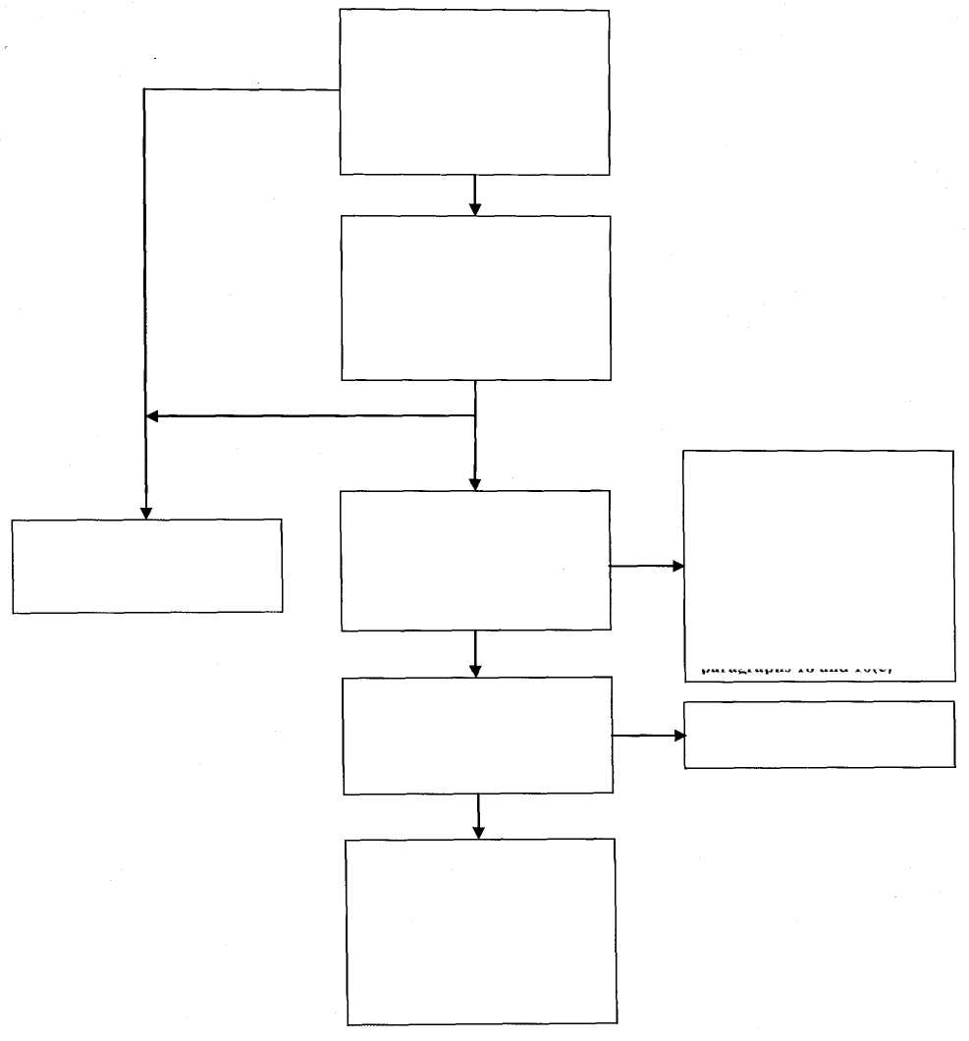

# Chart 4—Determining Acceptability of Legal or Regulatory Framework—CAS 210

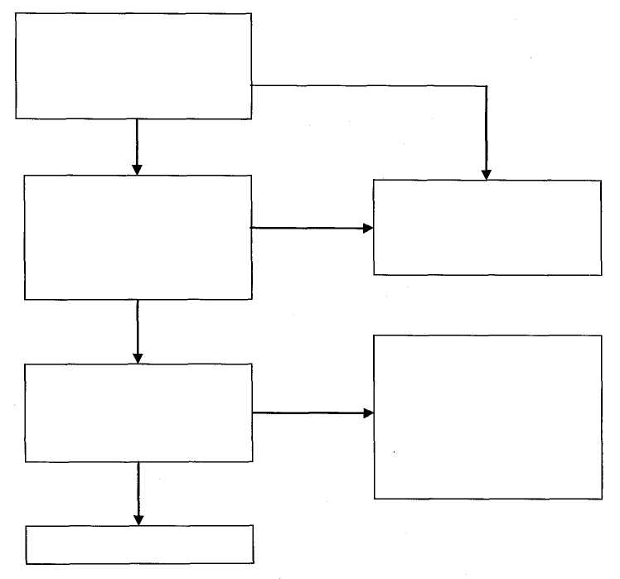CAS 210 recognizes that law or regulation may prescribe that financial statements be prepared in accordance with a financial reporting framework other than financial reporting standards. CAS 800 also recognizes this type of framework for special purpose financial statements. The following chart explains the logic flow with respect to this type of financial reporting framework.

Are there indications that the applicable financial reporting framework is **not** acceptable? **CAS 210, paragraph A9**

No

Yes

Can additional disclosures avoid the financial statements being misleading and will the conditions in CAS 210 paragraph 19(b) be met? **CAS 210, paragraph 19**

May accept engagement if other preconditions are present—go to Chart 5, framework 4(a)

Yes

No

Determine the type of modified opinion that will be required (CAS 705) and refer to this matter in the terms of the audit engagement—go to Chart 5, framework **4(b) CAS 210, paragraph 20**

Is the auditor required by law or regulation to undertake the engagement? **CAS 210, paragraph 20**

Yes

No

Do not accept engagement

# Chart 5—Impact on Engagement Acceptance—CAS 210

CAS 210 contains preconditions for an audit (including the condition that the financial reporting framework is acceptable) that must be met before the auditor can accept the engagement.

Frameworks 3(c) and 4(b)—auditor required to undertake the engagement and will issue modified opinion under CAS 705 (from Charts 3 and 4)

Frameworks 1, 2(a) and (b),

3(a) and (b) and 4(a) (from

Charts 1-4)

Are other preconditions for an audit present? **CAS 210, paragraph 6(b)**

Are other preconditions for an

audit present? CAS **210,**

**paragraph**6(b)

Yes

No

Yes

No

Accept engagement—go to Chart 6

Is the auditor required by law or regulation to undertake the engagement?

Determine the type of modified opinion that will be required (CAS 705) **CAS 210, paragraph 18 for framework 3(c) or paragraph 20 for framework 4(b)** and the implications for the auditor's report **CAS 210, paragraph A14**

No

Do not accept engagement CAS **210, paragraph 8**

Yes

Determine the type of modified opinion that will be required (CAS 705) CAS **210, paragraph 18 for framework 3(c) or paragraph 20 for framework 4(b)**

Determine the implications for the auditor's report **CAS 210, paragraph A14**

