TeamMate
User Guide -
Encrypted USB Key


Important - TeamMate and USB Keys 3
Installing the USB Key (First Time Only) 3
Installing the USB Key 6
Removing the encrypted USB Key 7
Stopping the encrypted USB Key prior to removal 8

Important - TeamMate and USB Keys
- You should only use the “Stealth MXP Encrypted USB key” with TeamMate. This USB key is encrypted and should be used for information up to Protected B ONLY.

Note: If your current USB key is not encrypted, please contact the helpdesk and they will issue you a new encrypted USB Key.

- Do not save any files in the “Restricted IT Zone” folder as they will be lost once the key is removed from the computer. SAVE ALL FILES TO THE “PRIVATE FOLDER”.

- Improper removal of the USB key will result in a computer crash. Instructions for proper removal of the USB key are found below.

Installing the USB Key (First Time Only)
- Attach USB Key to the USB port on your computer. If you wish you can use the extension cable provided to minimize the risk of damage to the USB port on your PC.

Your computer will automatically detect and install the USB Key.

When you connect the USB Key to you PC you will get the following message:
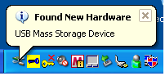

- When you get the following screen, Click on “OK” to Start MXI ACCESS Enterprise Client:
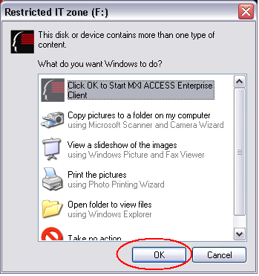

- Click on “Next” to enter your password:
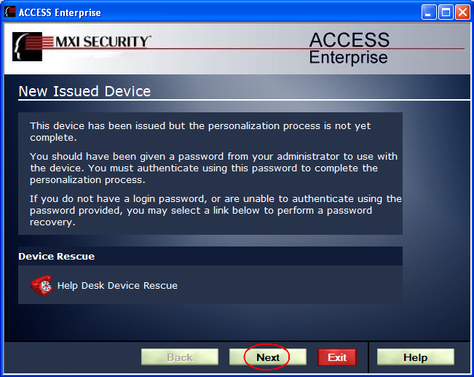

- Enter your password that was sent to you in “New secure USB Key” Email and Click on “Next” to continue:
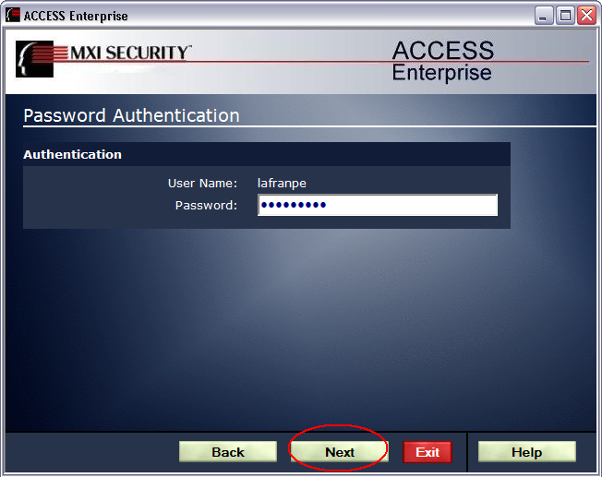

- Enter and confirm a new password and Click on “Next” to continue:
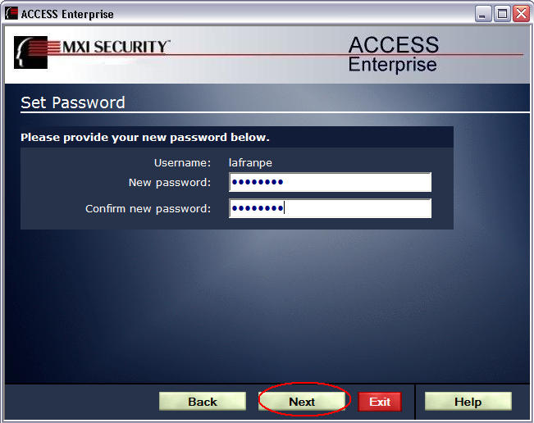

- Click on “Exit” to complete the process:
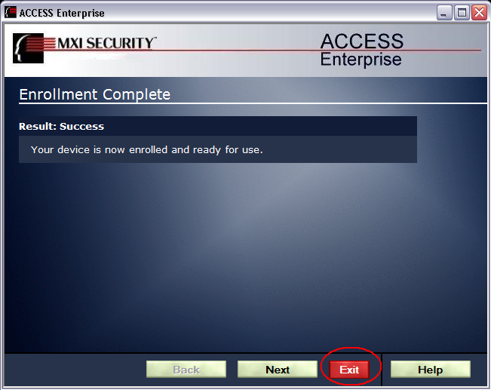

- Now you will be able to read and write files in the “PRIVATE” folder on your encrypted USB Key:
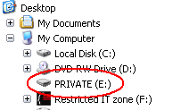

Installing the USB Key
- Attach USB Key to the USB port on your computer.

- When you get the following screen, Click on “OK” to Start MXI ACCESS Enterprise Client:

- Enter your password and Click on “Next”.

- Now you will be able to read and write files in the “PRIVATE” folder on your encrypted USB Key:

Removing the encrypted USB Key
The following are a few simple steps to help ensure all data is written and that the files are properly closed.

Before you remove the encrypted USB Key from the USB Port, you should make sure that:
- The Blue light on the USB Key is not flashing. This will ensure that your data on the device is not lost.

- If you are using TeamMate, please close TeamMate before attempting to remove the USB Key. TeamMate may keep files open thereby preventing safe removal of the USB Key.

- When unplugging the USB Key, you should double click on the “Unplug or Eject Hardware” icon in the system tray located in the bottom right of your screen:


Stopping the encrypted USB Key prior to removal
- Double Click on the USB Mass Storage Device
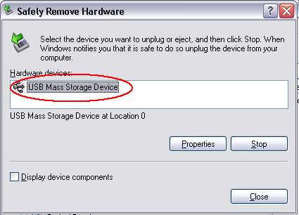

- Select “USB Mass Storage Device” and Click on “OK
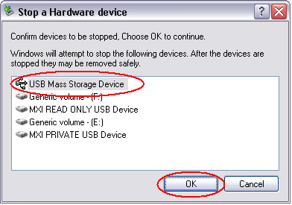

- If the USB has NOT been stopped successfully you will receive the following Message:
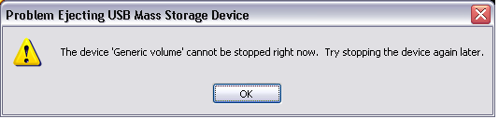

- Close TeamMate and Microsoft explorer and try to stop the USB Key again.

- When the USB has been stopped successfully you will receive the following Message:
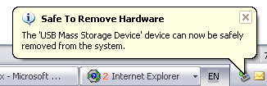

- You now can unplug the USB Key from the USB port.

Note: The USB Key should be removed before turning the computer off.

