**How to create a TeamMate file without rolling forward the prior year TeamMate file**

This document presents two options to import audit execution sections into a TeamMate file should you not roll forward the prior year Teammate file.

**Option 1: Create a TeamStore**

This option will allow you to export steps and working papers from selected folders. You can then import the steps and working papers using the TeamStore you created.

**Step 1 – Create a new TeamMate file**

1. Create a New TeamMate file.
2. Get the latest version of planning sections A to E, including working papers, from the offline AA TeamStore.
3. Create your permanent (PA section) file folders. Working papers will be imported to those folders at step 5.

**Step 2 – Send programs to User TeamStore (excluding work papers)**

1. **Copy** C:\Users\Public\TeamMate\TeamStores\User TeamStore.mdb to another location (ex: your desktop) as the version in the public folder is overwritten daily. The User TeamStore was created for users to be able to modify it, and you can add or replace as many times as you need.

**Note:** The TeamStore “User TeamStore.mdb” can be copied and renamed if the intent is to have one separate TeamStore for every folder.

Ex: “User TeamStore F.mdb” for folder F and “User TeamStore G.mdb” for folder G

OR “User TeamStore F.1.mdb” for folder F.1 and “User TeamStore F.2.mdb” for folder F.2

1. **Open** your old project
2. From the **Review** tab select **Send programs**
3. Click **Next**
4. Select relevant folders, click **OK**
5. Review the list of steps and click **Next**
6. Select **Send to Offline or other TeamStore**
7. Click **Browse**
8. Select the **User TeamStore** from your desktop.
9. Select options: 1, 2 and 4 as shown in the image below. Do not select “include linked work papers” as working papers will be added separately in step 3.

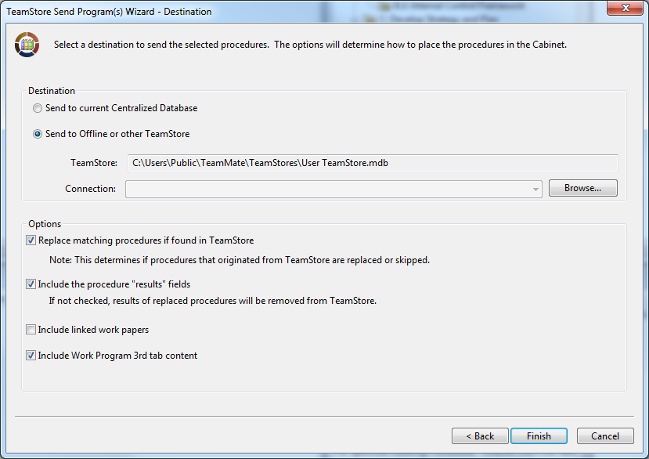

1. Click **Finish**
2. Select **yes** when prompted to send to off-line TeamStore.
3. Select **Cabinet 1** and click **Select**.

Your TeamStore is ready.

**Step 3 – Send work papers to User TeamStore**

This step might need to be done in batches if the file contains many working papers or the working papers are very large. If you get an “out of memory error” try again including only a select number of folders. Repeat the steps until all folders are sent.

1. From the **Review** tab and select **Send Working papers**
2. Click **Next**
3. Select relevant folders (including those from the PA folder), click **OK**
4. Review the list of steps and click **Next**
5. Select **Send to Offline or other TeamStore**
6. Click **Browse**
7. Select the **User TeamStore** from your desktop.
8. **De-select** option **Replace matching work papers**
9. Click **Finish**
10. Select **yes** when prompted to send to off-line TeamStore.
11. Select **Cabinet 2** and click **Select**. (Do not select the same cabinet used in Step 2)

Your TeamStore is ready.

N.B. If your TeamMate file’s structure is standard (Lead Schedule, Transaction Flow and Processes, Conduct Control Testing, etc.) and you export a complete file in a single cabinet, all working papers from the “Lead Schedule” folders, for instance, will end up into a single folder in the cabinet. Therefore it is suggested that you use one cabinet per execution file (ex: one for payroll, one for expenses, etc.).

**Step 4 – Import programs**

1. Open your new TeamMate project file.
2. From the **Home** tab select **Get Programs**
3. Select **Get from Offline or other TeamStore**
4. Click **Browse**
5. Select the TeamStore from your desktop -- double click or select **open**
6. **De-select** the option to import work papers as they will be imported separately.
7. Click **Next**
8. Select the programs to be imported in **cabinet 1** and click **get**.
9. Put in: **Newly created folders in browser** .
10. Click **Finish**.

**Step 5 – Import Working papers**

Documents must be imported **folder by folder**. This is very effective to populate the permanent file.

1. Go to one **PRG folder** or one **PA folder** and click **Add working paper**.
2. Select tab **Get from TeamStore** (see image below)
3. Select **Get from Offline or other TeamStore**
4. Click **Browse**
5. Select the **User TeamStore** from your desktop – double click or select **open**
6. Click **Get**
7. **Expand folder** for **cabinet 2**
8. **Select** the matching folder you selected in **step 5.1**
9. Click **Get** (to list selected working papers)
10. Click **Add** (to complete the import to one folder)
11. Repeat Steps 1-10 for each PRG and PA folder

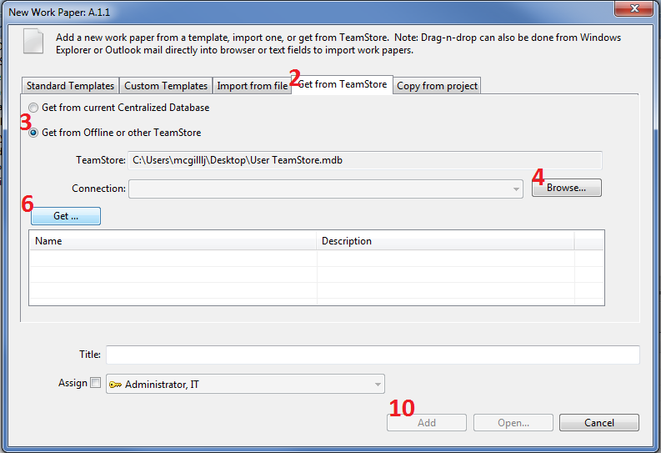

Helpful information and tips

* Add working papers: Documents imported in step 5 above will be in the same order they were in the TeamStore (ex: the prior year file). The files will be renumbered in sequential order. If the team does not want to import certain documents they can ensure they select only the working papers and they want to import. If some working papers are de-selected for import then the ARC numbers will renumber to fill those gaps. The hyperlinks in the working papers will no longer be active. These hyperlinks will need to be deleted and recreated.
* Hyperlinks: When the hyperlinks are active, they must be removed in the following way:
  + Right click on hyperlink / Remove Hyperlink

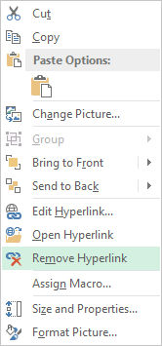

When hyperlinks are no longer active in a Working paper or a Program the icon can be deleted. It is important to properly delete an active hyperlink as described above. By deleting the icon of an active hyperlink, this hyperlink remains in the background and problems may arise (ex: increases the file size and can create problems within Excel/Team Mate).

* Replica: It can be efficient to work from a replica while performing steps 4 and 5. This gives the possibility to sync or merge the changes made in the replica to the master file as steps 4 and 5 are being performed. If the team wants to backtrack and start a step over, the replica can be discarded and the step can be performed with the information that is in the master file.

**Option 2: Export and import working papers only**

You can select multiple working papers to export to your hard drive in one step (right click on one of the working papers), and import them into your new file using “drag and drop” from your hard drive to a TeamMate section. Keep in mind that by doing so, your working papers will not show up in the same order as in your former file, unless you import them one by one. Depending on your preference, this option may be more time consuming.

Also, you may have come across working papers that did not get exported, due to a character in the title not supported by Windows or a file name that was too long. When you export make sure that all working papers you meant to export were actually exported to your hard drive.